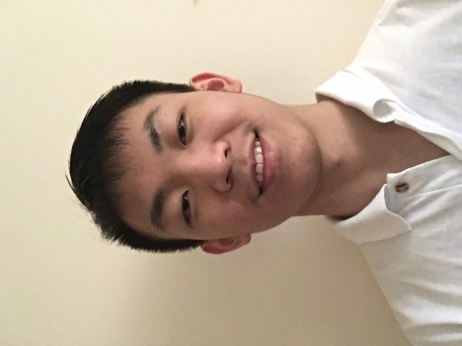

* (2015-2017): Bsc Computer Science in The University of Sheffield
  + 1st class
* (2014-2015): Sheffield International College (SIC)
  + Average score: 81%
* (2012-2014): Guigang Senior High School in Guangxi, China

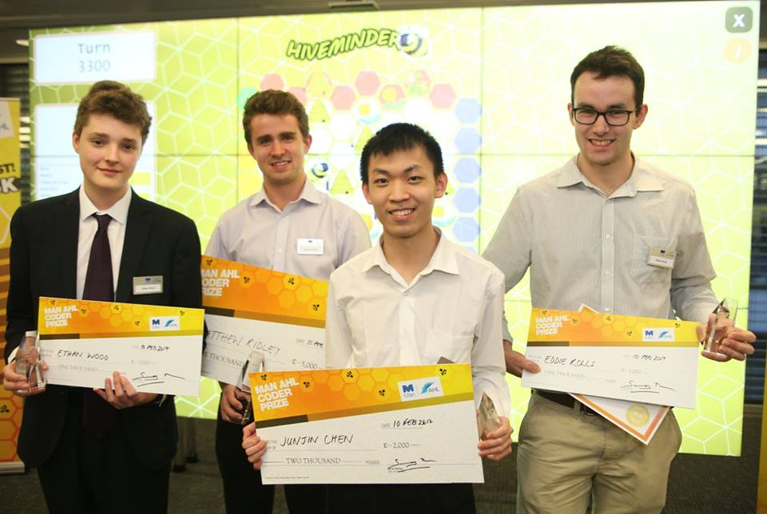

* Social Innovation Lab (establish a virtual company with partners)
  + Ability to think independently, Time management, Teamwork.
* 24 hours inspiration volunteer (Sell tickets and raise money for people suffering from cancer)
  + Receptionist skill
* 30 hours GameJam (create a game with given theme in 30 hours)
  + Creativity, Game design skill,

Time-Management Skill

* Pair Programming competition
  + Communication skill
* Photoshop Lessons
  + Aesthetics
* 2nd Prize in HiveMinder coding competition
  + Ability to well use the knowledge I learned
* Robot Art Placement (working with student in

Art department)

* + Robot programming skill, creativity,

teamwork

I chose Computer Science as my course because I love everything about the computer, such as the power of fast computing, large information storage and etc. This course has enlightened me a lot on the field of Computer, from the concept of programming (e.g. the structure of OO language) to complex algorithms (e.g. Reinforcement Learning) to software management (e.g. Agile Method). Within the course, some of my achievements were making Liquid democracy system for a client, analyzing data, performing machine learning and simulating models using python and etc. Outside the course, I would not miss the chance of participating in coding competitions such 30hrs game jam and HiveMinder algorithm challenge.

One big reward I got was the 2nd place with £2000 in HiveMinder competition. (more details at https://www.ahl.com/coderprize).

Now we have dissertation project and one of which has raised my interest, which is to apply deep reinforcement learning agent into a game called Starcraft2, with the opening source from DeepMind Company cooperating with Blizzard Entertainment. This project is quite challenging since it involves lots of theories about learning algorithm. Nonetheless, I managed to comprehend each terminology by doing some research. This project has enhanced my research skills as well as my understanding about AI.

Contact info

Current address:

86 Weston Street, Sheffield

S3 7NQ

Email: [1099404025@qq.com](mailto:1099404025@qq.com)

Phone no: 07340241601

Personal info

Born in: 2nd March 1997

Gender: Male

Nationality: Chinese

Language

* Mandarin
* English
* Cantonese

Programming language

* Java
* Python
* Haskell
* C++
* Ruby
* JavaScript
* Html
* CSS

Interests

Computer games, Ping Pong, listening to Music, Painting.

Junjin Chen